Harini S.N
Mail to: harinisenarajan@gmail.com
Contact @91-6381371389
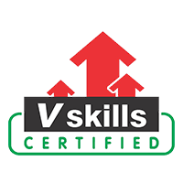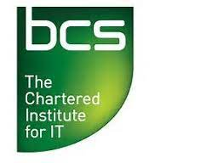

CAREER OBJECTIVE:
To succeed in an environment of growth and excellence which provides me job satisfaction and self –development and help me achieve personal as well as organizational goals.

EDUCATIONAL QUALIFICATIONS:

S.No | Qualifications | Board/University | Aggregate % | Year of Passing
1 | MCA | University of Madras | 75% | 2012
2 | BCA | Periyar University, Salem | 65% | 2009
3 | HSLC | State Board | 70% | 2006
4 | SSLC | State Board | 83% | 2004

TECHNICAL SKILL SETS:

Programming Languages | C ,CoreJava
Packages | MS-Office (Word, Excel, PowerPoint)
Automation tools | Selenium WebDriver, TestNG,Cucumber
Databases | MYSQL
Web Technologies | HTML,CSS,JAVASCRIPT

CERTIFICATIONS:

- ISTQB-ISEB Foundation level
- Certified Selenium Tester – Vskills

MINI PROJECT :
TITLE : WEB HOSTING
DESCRIPTION :
Web hosting is a service that allows organizations and individuals to post a website or web page onto the Internet. A web host, or web hosting service provider, is a business that provides the technologies and services needed for the website or webpage to be viewed in the Internet. Websites are hosted, or stored, on special computers called servers. When Internet users want to view your website, all they need to do is type your website address or domain into their browser. Their computer will then connect to your server and your webpages will be delivered to them through the browser.
Most hosting companies require that you own your domain in order to host with them. If you do not have a domain, the hosting companies will help you purchase one.
MAIN PROJECT :
TITLE : ENTERPRISE RESOURCE PLANNING
DESCRIPTION :
Enterprise resource planning (ERP) is the integrated management of main business processes, often in real time and mediated by software and technology. ERP is usually referred to as a category of business management software typically a suite of integrated applications that an organization can use to collect, store, manage, and interpret data from many business activities. ERP Systems can be local based or Cloud-based. Cloud based applications are growing in recent days due to information being readily available from any location with internet access.
ERP provides an integrated and continuously updated view of core business processes using common databases maintained by a database management system. ERP systems track business resources, raw materials, production capacity and the status of business commitments: orders, purchase orders, and payroll. The applications that make up the system share data across various departments (manufacturing, purchasing, sales, accounting, etc.) that provide the data. ERP facilitates information flow between all business functions and manages connections to outside stakeholders.

PERSONAL INFORMATION:
Father’s Name: S.Natarajan
DoB : 24.12.1988
Languages : Tamil and English
Hobbies : Gardening , Listening music
DECLARATION :
I here by declare that above information is correct to the my best of knowledge and belief.

(HARINI S N)

